- Purpose

The purpose of this procedure is to put into detail how to properly operate main MgO mix pot, located on top of digester #4.

- Scope

This procedure applies to the main MgO mix pot located on top of digester #4.

- Responsibility

Lead Operators, Process Operators

- Safety Considerations

Safety shoes and safety glasses are required when working in, on, or around the digesters. Sulfuric acid is highly corrosive to clothing and the human body. If you come into contact with it, immediately flush the affected area(s) with water for 10 minutes.

Safety is a condition of employment. Employees are not authorized to work in an unsafe manner and are prohibited from harming the environment of the facility or community.

- Materials/Equipment

- Monitoring System

- Procedure

NOTE: The Main MgO Mix Pot must be started separately, and before, Digester #4 is started. Digesters 1, 2 and 3 have their own mix pots. Their operation is not tied to the Main MgO Mix Pot described in this procedure.

  - Start the Main MgO Mix Pot per P17-PR-200-097.
  - Once started, the MgO feed and discharge to the digester can be controlled.
  - From this screen:
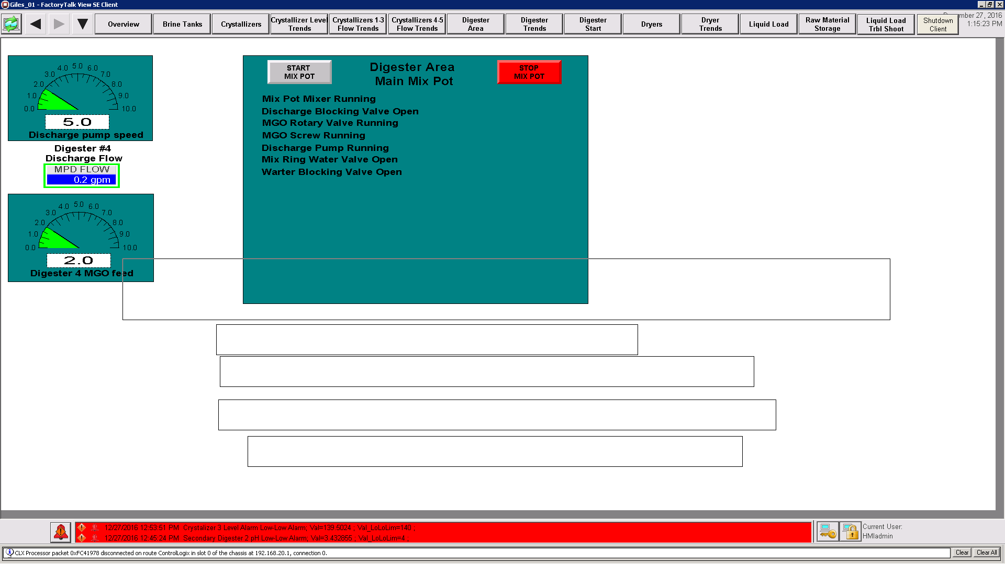

The setpoint for the MgO feed can be controlled by clicking this botton:

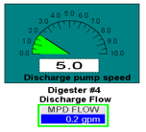

The setpoint for the feed to the digester can be controlled by clicking this button:

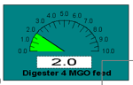

In case of emergency, stop the Main Mix Pot per procedure P17-PR-200-097.

- Reference Documents

Starting and Stopping the Main MgO Mix Pot (P17-PR-200-097)

- Change Information

Document review:
- New document

